CSC 317:  
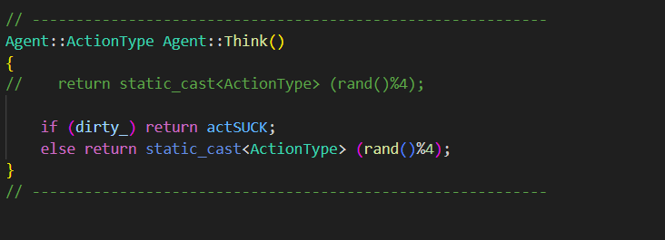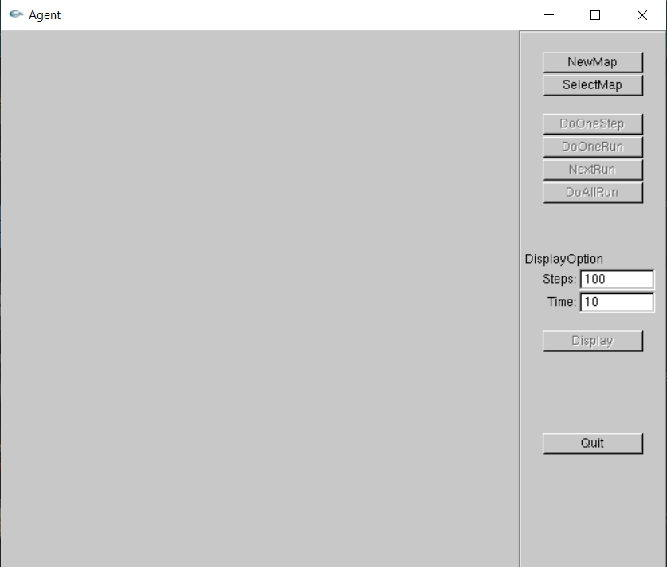

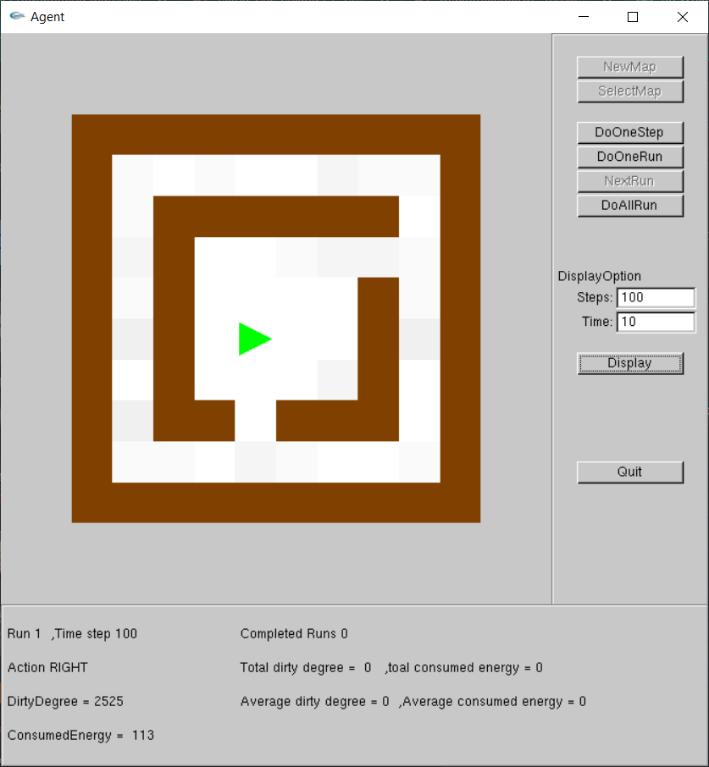

What we learned:

* It is a random automatic vacuum cleaner.
* The grey points represent the dirt
* The steps param allows us to dictate the number of steps the Vacuum Cleaner should make at a go.
* When you click display, it randomly moves a vacuum cleaner to a certain spot.
* In case the spot has dirt, the vacuum cleaner will clean the dirt.
* Consumed energy: 1 energy bar per movement, 2 energy bars as it sucks the dirt. It will increase the consumed energy per movement and cleaning
* The vacuum cleaner will suck the dirt in case there is dirt, however, if there is no dirt, it will perform a random action specified by the (rand()%4) function which will give a remainder of values between 0 and 3. These numbers will specify the action to be performed from the ActionType function. The functions are as follows:
  + actUp
  + actDown
  + actLeft
  + actRight